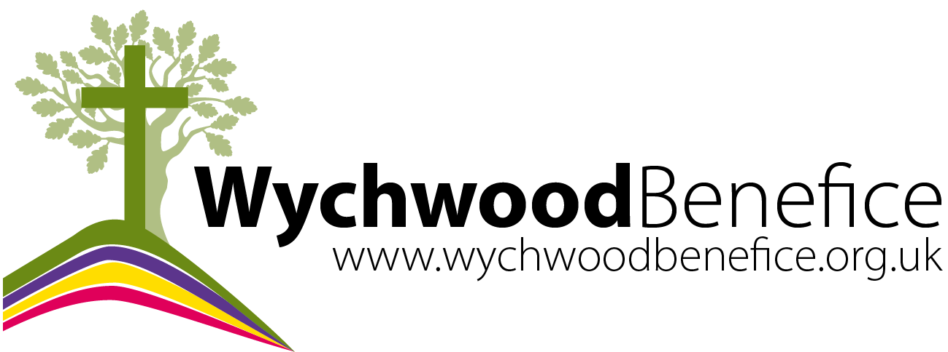

Summer 2020: Have your say on the new pattern of services
In early September we will be reviewing our current plan of holding one Communion service per Sunday rotating around the 4 churches of the benefice.

This is an opportunity to think about what we would like for this next period of time, when we are allowed to meet in our buildings, albeit in a restricted way.

We should think about what has been good about worship during lockdown in our benefice and beyond. The online services, online coffee morning, homegroups, Messy Church takeaways and more.

As some people are able to come back to church, others may prefer or need to stay away for some time. How can we include everyone?

Holding a limited number of Holy Communion services may be something we need to continue for the time being but there are other ways we could get together in our churches with your help.

Do let us know what you think. Here are some of the questions to consider:

- Have you watched the online services -either the benefice’s or other? Would you like an online element to continue?

- Would you like to attend services in church/how often/ what style of service?

- Would you like the chance to meet regularly (weekly?) at the same time in your parish church for a different kind of event - a short service, prayer, café church, other?

- Do you have any ideas on what our churches could be used for during this next phase?

- Would you be willing to be part of a team to help organize or run something regular in your parish church (with support)?

- Do you have any ideas on how we might approach some of the bigger festivals differently to include more people (Harvest, All Souls, Remembrance, Christmas)?

Any other comments:

We will be collating everyone’s feedback at the end of August and then putting together a suggested plan for the next few months.

Please send your thoughts, comments and suggestions to Geoffrey, Anne or the office email or church room post box before the end of August.
office@wychwoodbenefice.org.uk vicar@wychwoodbenefice.org.uk anne@wychwoodbenefice.org.uk

